Regarding the evaluation process, you mention that "After training, each client evaluates the model on a shared test set." Please clarify whether clients possess their own testing data in addition to this shared set. Providing more detail on the composition and purpose of the shared test set would be beneficial.
Clarifying the evaluation procedure
No client-specific test sets are used.
Each client owns only its local training shard (10 % of the 60 000 MNIST training images in our final experiments).
Clients do not keep a private test/validation split; this keeps the storage footprint identical across devices and eliminates variability in evaluation statistics that would arise from ten different test distributions.
What is the “shared test set”?
We distribute one identical, hold-out dataset (MNIST test split, 10 000 images) to every client after each communication round:
- Server broadcast – The server includes a 10 000-sample tensor object (≈ 28 MB) in the evaluate instruction.
- Local evaluation – Each client runs a forward pass, computes loss and accuracy, and returns only those two scalars.
- Aggregation of metrics – The server averages the ten scalar losses / accuracies to log a single number per round.

The shared set is never used for training; it serves exclusively to obtain a round-by-round, performance curve for FedAvg, Median, and Weighted-Median.
Using a common test set—rather than ten private ones—ensures that differences we observe are due to the aggregation rule, not to different evaluation distributions.
On page 4, there appears to be an incomplete sentence: "Clients whose updates are too far from aggregation...". Please complete this sentence to ensure clarity
Clients whose updates are too far from the layer-wise median—measured by the average L2 distance across all model layers—are excluded from the current round’s aggregation.

In the section on median aggregation with outlier filtering, you employ the criterion "Q3 + 1.5 * IQR" for client filtering. It would be helpful to indicate whether this is a standard statistical approach. If it's a non-standard approach, please provide a justification for its selection.
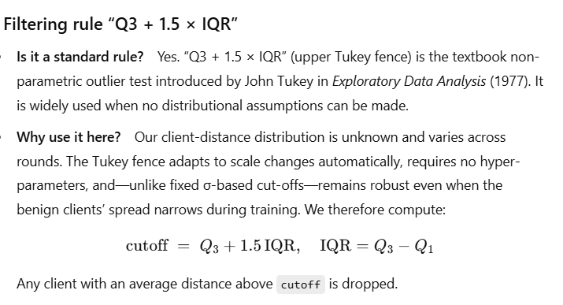
When describing the stochastic client availability model, you mention that "the launcher script randomizes the selection of clients participating in each round." Please provide further details on the client selection ratio used in your experiments and specify the frequency with which malicious clients were included in the aggregation process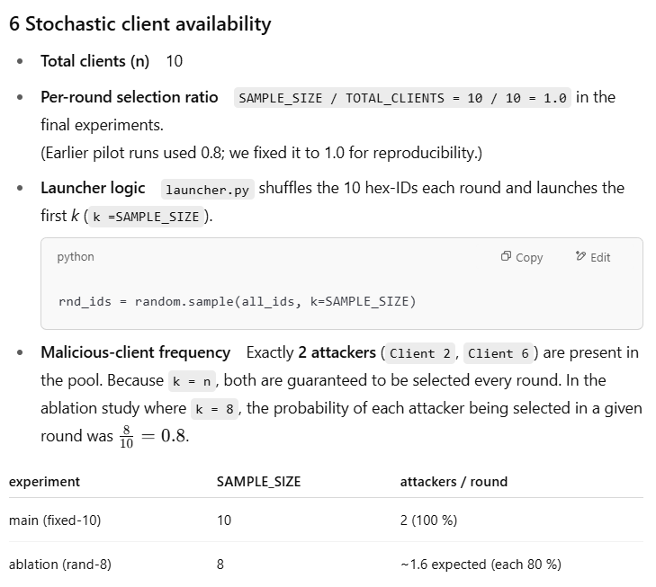

So we have 10 clients and we are poisoning 20%. The selection ratio is how many clients we are using per round in this case we are using 100% of the clients, this is expressed by SAMPLE_SIZE / TOTAL_CLIENTS and we know that we are randomizing 2 attackers per round so for sure 2 attackers will be present and poisoning each round.
Please elaborate on the specific criteria used in your experiments to classify clients as attackers or non-attackers.
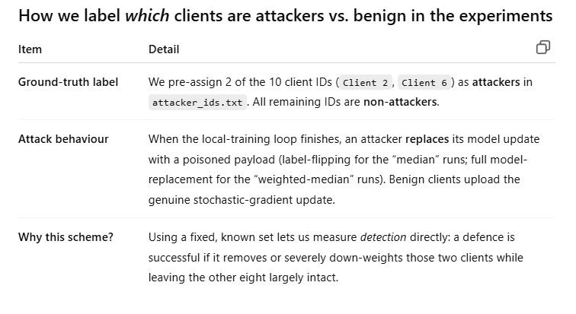
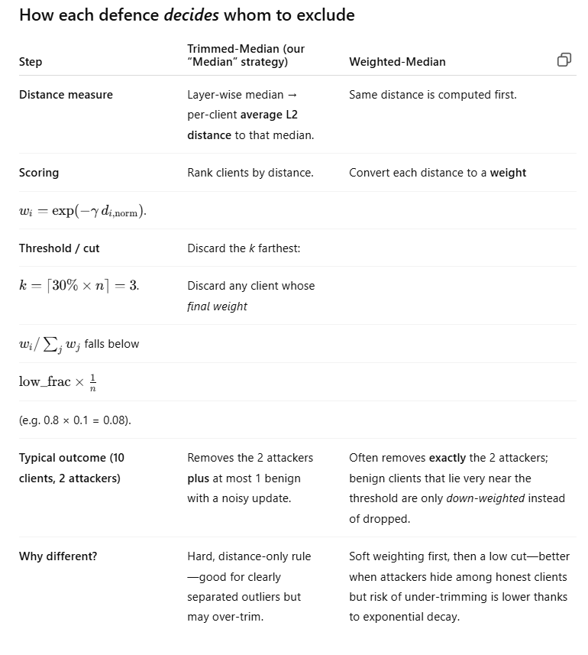
In our case, the median removes 1 or 2 benign clients and the weighted removes 2 or 3 benign clients.
This sums it:
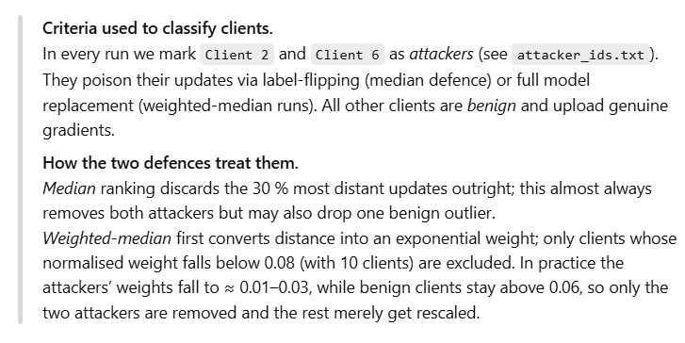
I want you to incorporate graphical representations of your results, such as plots and tables. Consider moving some of the more technical implementation details to an appendix to create more space for these visual aids
All the Graphs are attached on the other docs

